Process Simulation using PRO/II's GUI

General Approach to Simulation

red borders - operations required, and data fields where data entry is needed
green borders - Data entry fields with supplied defaults. After supplying information in an entry field, the border changes to blue. If you supply data outside the normal range of values for a field, a yellow border appears.

Data may be supplied in almost any order; PRO/II warns you when required data are missing.

However, the following general approach is recommended:

1. Draw the flowsheet and connect the unit operations with streams.
The icons and names for the unit operations appear in the PFD Palette which may be moved or resized as desired. To add a unit operation to the flowsheet, click the unit icon in the palette, move the cursor to the desired location on the draw area, and click the left mouse button. The icon for the unit will be placed on the flowsheet.
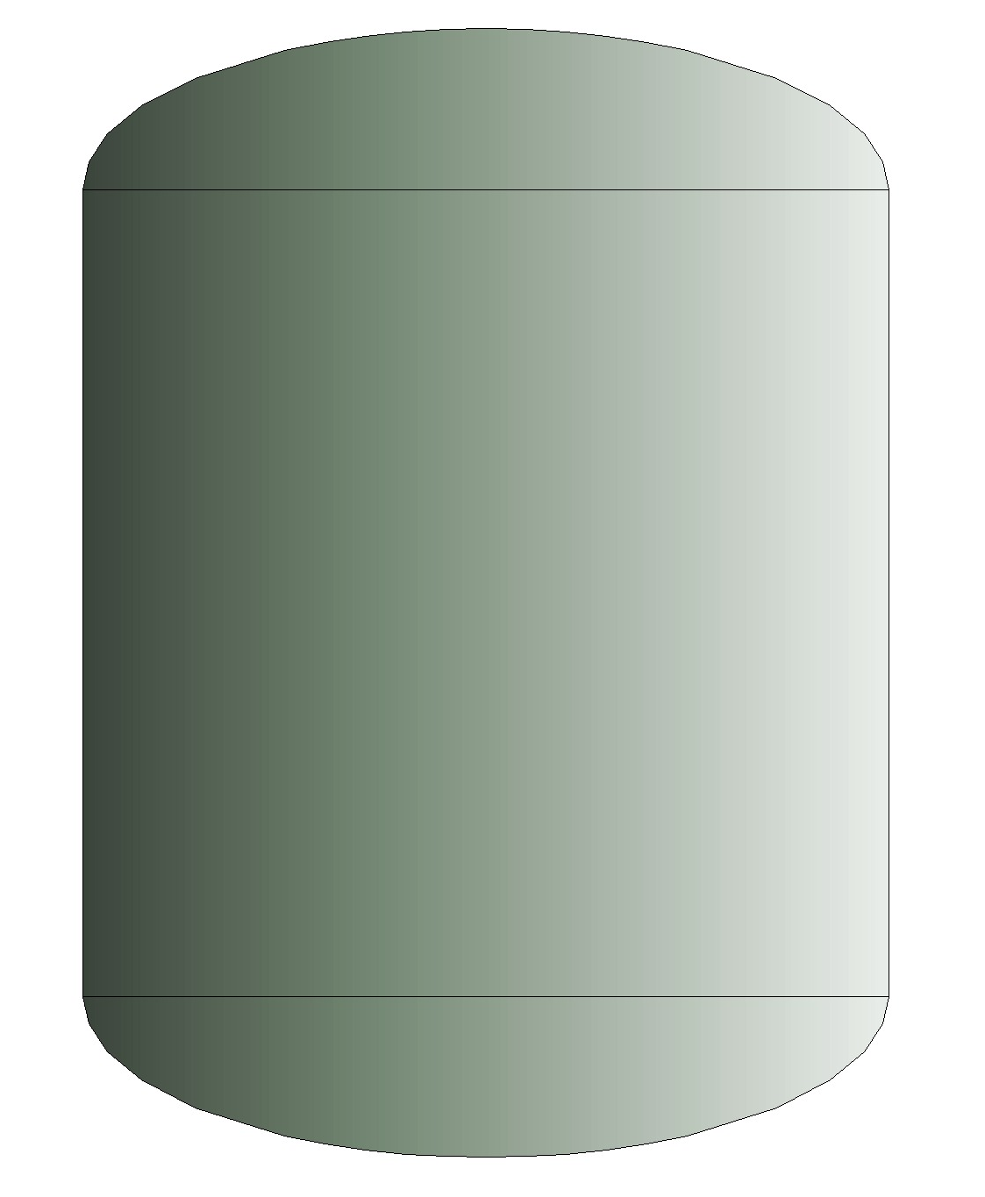
e.g., For a flash calculation:
- Click on the flash drum (located in panel on RHS).
- Mover cursor to Pro II Flowsheet and click mouse
- From the PFD Palette, push the Stream button. The cursor changes its shape to and all possible exit ports for each unit operation are now marked. Required outlet ports are red; optional ports are green.

2. Define the components in your system.
It is best to order the components in volatility order, starting with the lightest component. While not a necessity, defining water as the first component in hydrocarbon/water systems makes it easy to see the break between the aqueous and non-aqueous phases. Petroleum components for which you supply data should be defined next. Pseudocomponents generated by PRO/II from petroleum stream assay data are the last components in the component list.

3. Select the thermodynamic and transport property methods.
For many problems, a predefined method set may be selected. Guidelines for thermodynamic methods are provided in the PRO/II on-line help and Reference Manual (accessed via the Help Menu), and the hard copy PRO/II Reference Manual. Hot line help is also available from SimSci.

4. Supply data for the feed streams and recycle streams.
You must supply thermal conditions, flowrates, and compositions for all external feed streams to the flowsheet. Optionally, estimated data may be supplied for recycle streams to speed convergence of recycle calculations.

5. Supply operating conditions for the unit operations.
Double-click on the icon for each unit operation to access its data entry windows. The color codes tell you what data you must supply and what data have defaults. You may also use the on-line help (accessed via the Help button) to learn more about the calculation options, data entry items, etc.

6. Run the process simulation.
PRO/II uses color codes to let you know when sufficient information has been supplied to perform the calculations. When all stream and unit labels and all the borders for the toolbar buttons have changed from red (indicating missing data) to green or blue, you are ready to run your simulation. At this point, you may push the Run button on the toolbar to begin flowsheet calculations.

7. Analyze the simulation results.
Use the many convenient report and plotting features of PRO/II to analyze the simulation results. At this point some careful engineering analysis is in order. Are the calculated results reasonable? How do the results compare with the plant data? Can differences be reconciled? Are better data needed for the feed stocks? Is the model adequate for the intended purposes?

Now that we have presented an overall plan for simulating a flowsheet, let's look at some of the individual steps in more detail.

