Specific Modules in Pro II

This document will focus on three specific pieces of equipment in Pro II: flash drum, distillation column and Gibbs reactor. Because the flash drum and distillation column do not require specifying a reaction they will be covered first.

Flash Drum
The initial set up is the same as covered in “Introduction to Pro II” so it will be assumed that the PFD is set up with the proper components and thermodynamic package. Place the flash unit in the PFD space.
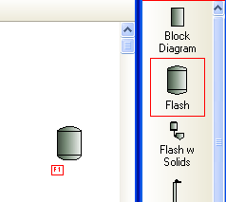
Then press the “Streams” button 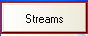 and connect the feed stream to the left side of the flash drum and product streams to the top port and the side port. (Note: while it’s not critical to not connect the bottoms stream to the bottom port, the bottom port is normally reserved for decanted water or second liquid product.)
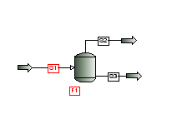
Define the inlet stream S1 in the standard fashion described in “Introduction to Pro II.” Double clicking on the flash drum will open the specification window (shown below). Here the unit can be renamed by typing the desired name in the “Unit:” field, currently F1. The flash drum will require two specifications. The first specification can be either: pressure drop, operating pressure or operating temperature. The second specification can be defined from the flash drum as: temperature (if pressure or pressure drop is selected as the first specification), pressure or pressure drop (if temperature is selected as the first specification), duty, dew point, bubble point, isentropic or upper dew point (if temperature is selected as the first specification). Alternatively, the second specification can be defined from the product. To do this select the “Product Specification” radio button.
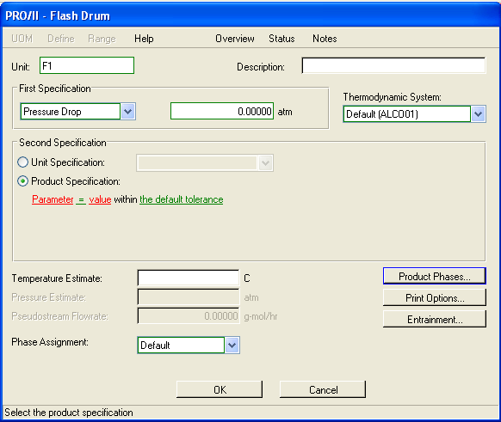
To define what will be the specification click Parameter. This will open the following window.
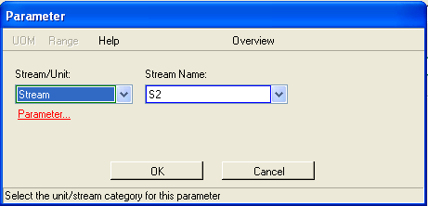
The only option here is to have the parameter be in one of the product streams. Choose the desired stream from the “Stream Name:” drop down menu. Once the stream is chosen click on Parameter again to open this window.
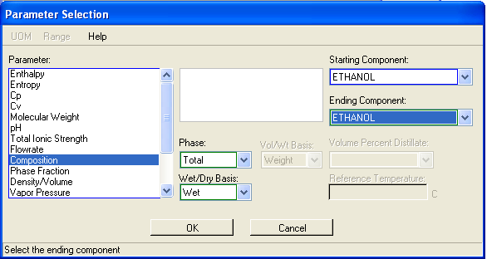
In this window the parameter to be fit to in the selected stream can be chosen. This example is selecting composition of one of the product streams to be the parameter fit to. The list of possible parameters is shown in the figure and also includes: transport property, heating value, distillation curve, refinery inspection property and user-identified special property. Once the parameter has been selected click “OK” to save the changes. The new parameter will appear highlighted in blue and the units that will be used are in green. If these are acceptable click “OK” again, if not either the parameter can be changed by clicking on it again, the units can be changed by clicking on them. Once the parameter has been set, the value can be set by clicking on “value” which opens a string field as shown below. Enter the desired value into this field
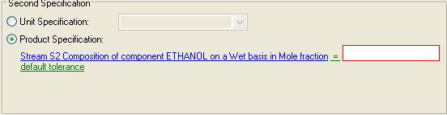
At this point the flash drum is sufficiently specified to solve properly. Note: if further specifications are made the system will become over specified and may not solve. Now the user can calculate the PFD by pressing theicon or 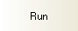 in the “Run Palette.” The system will become colored blue if everything is able to be calculated.
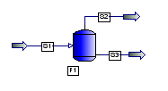
Results can be viewed as described in “Introduction to Pro II.”

Distillation Column
The initial set up is the same as covered in “Introduction to Pro II” so it will be assumed that the PFD is set up with the proper components and thermodynamic package. Place the distillation unit in the PFD space.
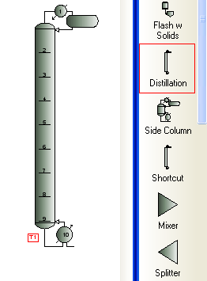
As soon as the column is placed a window will appear asking for the number theoretical trays to be used and whether to include a condenser and reboiler.
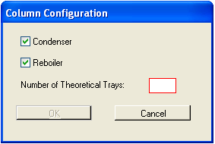
Note: all of these can be changed after the column has been placed.
Then press the “Streams” button to begin connecting streams. Connect the feed stream to the left side of the distillation column. The condenser has several port connections.
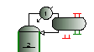
The top port is normally vapor product, while the bottom red port is liquid product and the bottom green port is water. These identifications can also be seen by hold the stream cursor over the individual ports. For this example we will be connecting the liquid product port from the condenser.
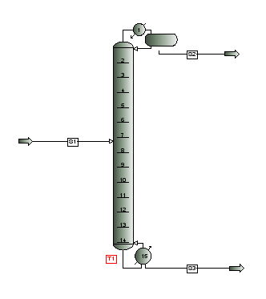
Define the inlet stream S1 in the standard fashion described in “Introduction to Pro II.” To define the distillation column several factors need to be defined. Double click on the column to open the specification window.
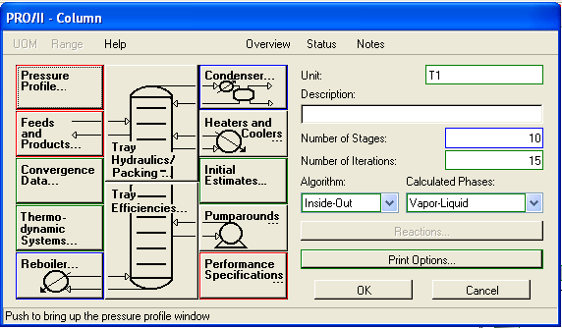
Notice at this point “Pressure Profile,” “Feeds and Products” and “Performance Specifications” need to be defined indicated by the red boarder. The “Condenser” and “Reboiler” are defined by defaults, indicated by the blue boarder. “Convergence Data,” Thermodynamic Systems” and Initial Estimates” are all user optional, they can be defined or redefined but it is not necessary, indicated by the green boarder. “Heaters and Coolers” and “Pumparounds” are optional additions to the distillation column. The column can be renamed by typing the desired name into the “Unit:” field, currently T1.
Clicking on “Pressure Profile” will open this window.
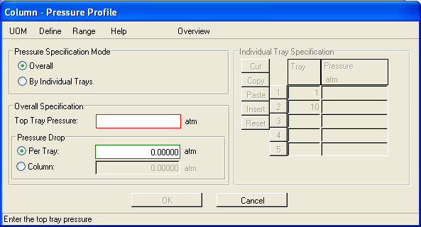
The pressure in the column can be defined either by the overall column or by the individual trays. To change between these two systems select the appropriate radio button. Overall requires the top tray pressure and the overall pressure drop, either per tray or across the whole column. By individual trays allows the user to specify the pressure on individual trays. The minimal trays to define are the top and bottom trays. Once the pressure profile for the column is defined press “OK” to save the changes and return to the “Column” window. If the pressure profile is properly defined that box will now have a blue boarder.
Clicking on “Feeds and Products” will open this window.
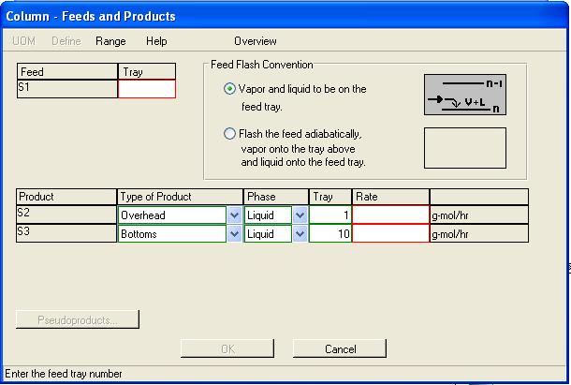
“Feeds and Products” is where the user defines what tray the feed stream will flow to. Here the user can also set whether both the vapor and liquid from the feed stream will go to the feed tray or if the feed will flash when entering the column. If the feed is flashed the liquid portion of the feed stream will go to the feed tray, while the vapor will go to the tray above the feed tray. In addition, an estimate of one of the two product stream flow rates is needed. Both streams flows have red boarders, but once one is defined the other becomes set. Setting both streams can lead to overspecification of the system. Once the feed tray and a product flow rate have been set click “OK” to save the changes and return to the “Column” window. If the feed tray and product streams are properly defined that box will now have a blue boarder.
Note: if “Performance Specifications” have not been set at this point Pro II will prompt the user if they want to set the product flow rate as a specification. If the user does this the flow rate will not be an estimate but a factor that Pro II will try to fit to.
Clicking “Performance Specifications” will open this window.
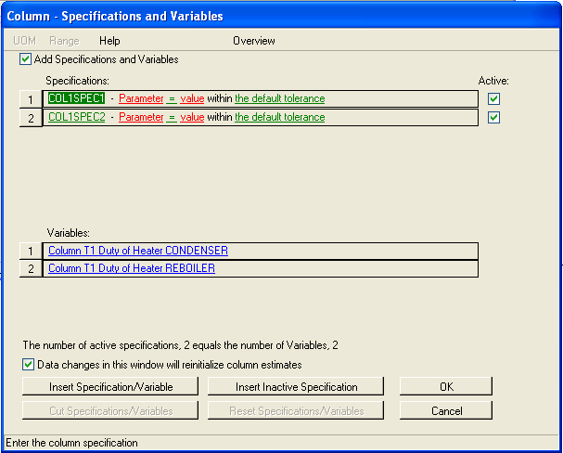
Note: if condenser and/or reboiler have been added and/or removed since placing the distillation column they may not be preset as variables.
The distillation column has a wide variety of possible parameters to fit to. This example will use one parameter from the column and one parameter from a product stream; however, it is possible to define a distillation column just using column parameters or stream parameters. Start by clicking on “Parameter” in the “COL1SPEC1 line. This will open this window.
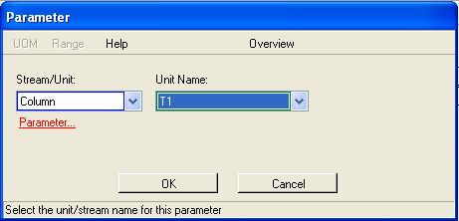
Under the drop down menu select either unit or column, here column was selected.
Note: only the column being defined will appear under unit name, even if there are multiple distillation columns in the PFD.
Then click “Parameter” to select the column parameter to fit to and open this window.
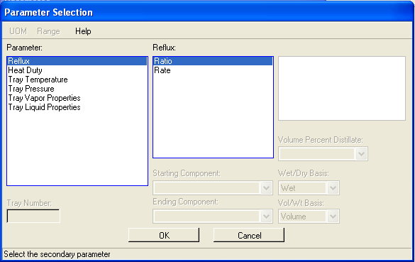
All possible parameters appear in the window. Each one has multiple sub choices and/or can be set for individual trays. This example will be using a fixed reflux ratio as a fitting parameter. Once the parameter has been selected click “OK” to save the changes. The new parameter will appear highlighted in blue and the units that will be used are in green. If these are acceptable click “OK” again, if not either the parameter can be changed by clicking on it again, the units can be changed by clicking on them. Once the parameter has been set, the value can be set by clicking on “value” and entering the desired value in the string field that appears. Repeating this process for line COL1SPEC2, but instead selecting “Stream” and the desired stream name (all product streams from the column are options) in the first parameter window that appears will open this window.
In this window the parameter to be fit to in the selected stream can be chosen. This example is selecting composition of one of the product streams to be the parameter fit to. The list of possible parameters is shown in the figure and also includes: transport property, heating value, distillation curve, refinery inspection property and user-identified special property. Once the parameter has been selected click “OK” to save the changes and follow the same steps as before to finalize the fitting parameter.
The other parameters that can be set in the “Performance Specifications” window are the variables that will be modified in fitting the column. The condenser and reboiler duties are the default variable, but these can be changed by clicking on them. Doing so opens this window.
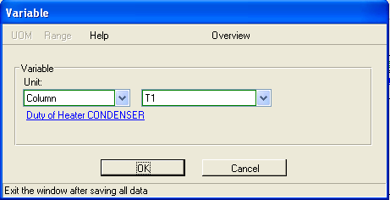
Note: only parameters in the column are possible variables.
The possible variable are shown in the figure below.
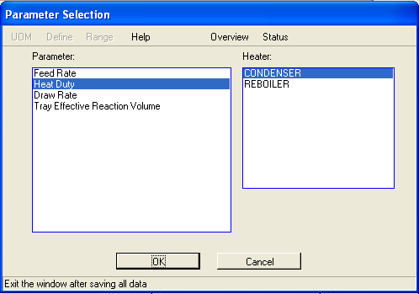
Depending on the system it may be more appropriate to modify parameters other than the duties to the condenser or reboiler. Additional specifications and variable may be added by clicking , however, the number of specifications and variables should be the same. An inactive specification may be added by clicking . It is also possible to make any specification active or in-active by checking or un-checking the active box next to it. Selecting any of the specifications or variables will allow for use of and. “Cut” will remove the selected specification or variable. “Reset” resets the specification to “Parameter” to be entirely redefined by the user. Pro II will inform the user if the number of specifications is not the same as the number of variables. Once all specifications and variables are set appropriately click “OK” to return to the “Column” window. If the specifications and variables are properly defined that box will now have a blue boarder.
At this point the system should be ready to run. It is a good idea to check that the condenser and reboiler are properly set.
Clicking on “Reboiler” will open this window.
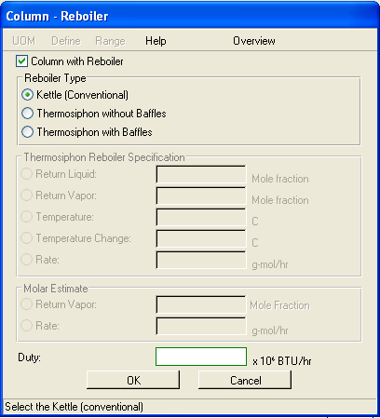
The Kettle reboiler is the default. In this window the user can also set the reboiler duty if it is known.
Clicking “Condenser” will open this window.
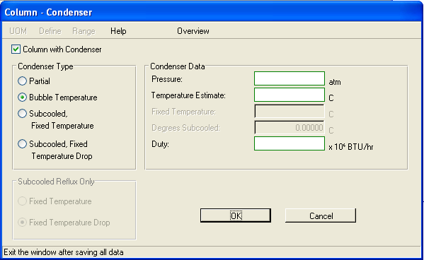
The default in this window will change depending on which product streams are connected. Notice that currently all of the parameters under “Condenser Data” have green boarders. This indicates that the user can set them if they’re known, but they do not need to be set.
“Convergence Data,” Thermodynamic Systems,” Initial Estimates,” “Heaters and Coolers” and “Pumparounds” will not be covered here as none of them are necessary to set to converge the distillation column.
At this point the flash drum is sufficiently specified to solve properly. Note: if further specifications are made the system will become over specified and may not solve. Now the user can calculate the PFD by pressing theicon or in the “Run Palette.” The system will become colored blue if everything is able to be calculated.
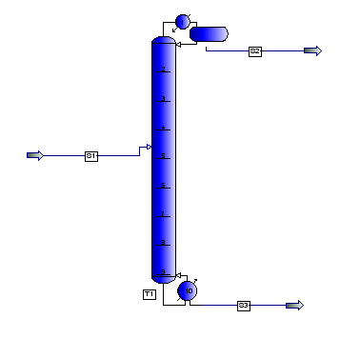
Results can be viewed as described in “Introduction to Pro II.”

Defining a Reaction
Pro II is capable of modeling chemical reactions.
Note: Pro II can handle multiple thermodynamic packages. It may be necessary to have one package defined for the reactions, while having another package defined for the equations of state.
After defining the chemical components as described in “Introduction to Pro II” select “Reaction Data” under “Input” or click on the icon. This will open the Reaction Data window.
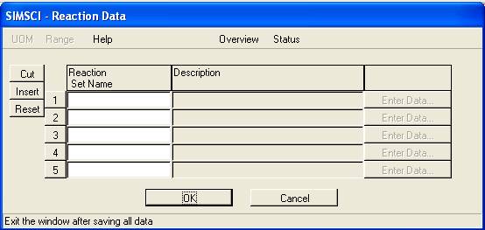
Here the user can name all of the reaction sets to be used in the system.
Note: a reaction set will be all of the reactions that take place in a given piece of equipment. This can be anything from one reaction to an entire reaction sequence.
After naming the reaction set click on which will have a red boarder and open the “Reaction Data – Reaction Definitions” window.
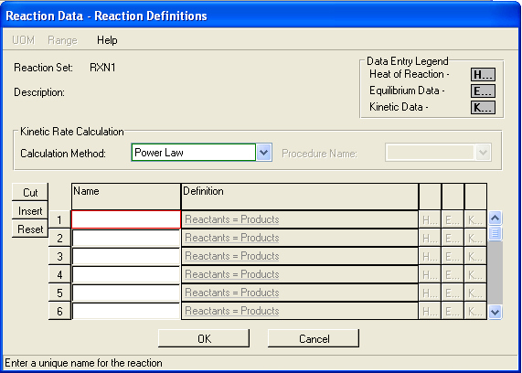
Here each individual reaction can be named and defined. Once a reaction has been named “Reactants=Products” will become red and the user can click on it, doing so opens this window.
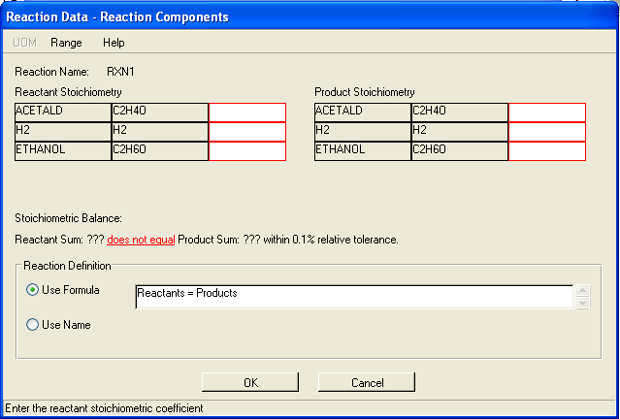
Here the reaction stoichiometry for the reaction is defined. Pro II can handle non-integer stoichiometries if a reaction requires them. Pro II has a built in check function that will check if the components on the reactants side equal the components on the products side. Once the stoichiometry has been properly defined click “OK” to return to the “Reaction Data – Reaction Definitions” window.
Note: at this point “H” “E” and “K” can be selected to allow the user to set the heat of reaction, equilibrium data, or kinetic data respectively.
Once all reactions for a given set have been defined click “OK” to return to the “SIMSCI – Reaction Data” window. Once all reaction sets have been defined, click “OK” to save the changes to the system.
To place the Gibbs reactor in the PFD select the Gibbs reactor from the PFD palette (it’s about 2/3s of the way down the palette).
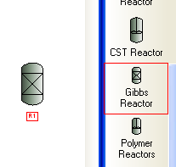
Connect and define streams in the usual manner. The Gibbs reactor only has input side and output side, there are no specific ports to connect streams to. Once the streams have been attached, double click on the Gibbs reactor to define its operation parameters, this is done in this window.
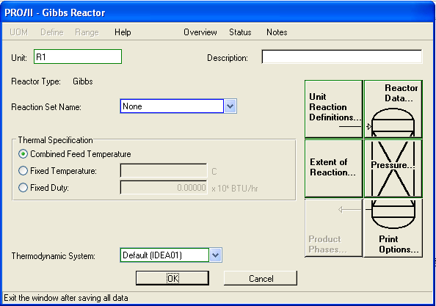
Under “Reaction Set Name” select the desired reaction set, defined from before. The user can also define how the reactor will be defined. The user can select from fixing the temperature based on the feed temperatures, fixing the temperature of the reactor itself or setting a duty to the reactor. Because the options are not required to solve the Gibbs reactor, only brief descriptions of each menu will be given.
Unit Reaction Definitions: the user can set what phase the reaction is occurring in. Default is “Calculated”
Rector Data: the user can set the maximum number of iterations to attempt while solving, the tolerance for the system, any phase split parameters, any user-defined atomic groups and estimates for the rates of different reacting components.
Extent of Reaction: the user can set either the percent conversion for a component or a production rate.
Pressure: the user can set either a pressure drop across the reactor or the outlet pressure of the reactor.
Print Options: the user can chose to show the calculation path for the enthalpy balance.
Once the reactor is defined the system is ready to solve. Now the user can calculate the PFD by pressing theicon or in the “Run Palette.” The system will become colored blue if everything is able to be calculated.
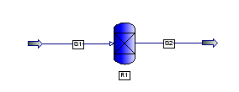
Results can be viewed as described in “Introduction to Pro II.”

