INSY 4970/7970/7976 – ANALYTICS AND VISUALIZATION OF Big DATA
Homework Set 3

Due: Thursday, March 7, 2013

Recommendations:
This homework aims to build on your understanding of the topics covered so far in chapters 3, 7 and 11. The exact topics covered in these three chapters have been highlighted in the presentations. Additionally, your colleagues have provided great supplementary material on the blog. Therefore, please review your class notes, textbook and the blog posts prior to attempting the homework. As discussed earlier, this class is designed such that the learning occurs during the class, but also outside the class (through the blog and Piazza platforms). By not thoroughly reading the posts and contributions on these two platforms, you are missing on two valuable learning opportunities.

Question 1: (2 point)
Find the set of 2-shingles for the "document":
ABRACADABRA
and also for the "document":
BRICABRAC.

After answering the two questions above, please answer the following:

- How many 2-shingles does ABRACADABRA have?
- How many 2-shingles does BRICABRAC have?
- How many 2-shingles do they have in common?
- What is the Jaccard similarity between the two documents"?

Question 2: (2 points)
Consider the following matrix:
 | C1 | C2 | C3 | C4
R1 | 0 | 1 | 1 | 0
R2 | 1 | 0 | 1 | 1
R3 | 0 | 1 | 0 | 1
R4 | 0 | 0 | 1 | 0
R5 | 1 | 0 | 1 | 0
R6 | 0 | 1 | 0 | 0
Perform a minhashing of the data, with the order of rows: R4, R6, R1, R3, R5, R2. Note: we give the minhash value in terms of the original name of the row, rather than the order of the row in the permutation. These two schemes are equivalent, since we only care whether hash values for two columns are equal, not what their actual values are.

Question 3: (2 points)
A dendrogram is a picture showing how points are merged in a hierarchical clustering. For example, in the dendrogram below, we can tell that at some time, points c and d were merged with each other before being merged with any other points. The cluster {c,d} was later merged with the cluster consisting only of point b, and so on.
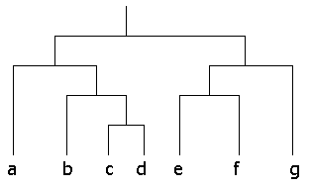
How many clusters of each size are described by the dendrogram above? Identify all the correct choice from the list below.
- There are seven clusters of size 1.
- There are six clusters of size 3.
- There are no clusters of size 7.
- There are two clusters of size 5.
- There are no clusters of size 6.

Question 4: (2 points)
Perform a hierarchical clustering of the following six points:
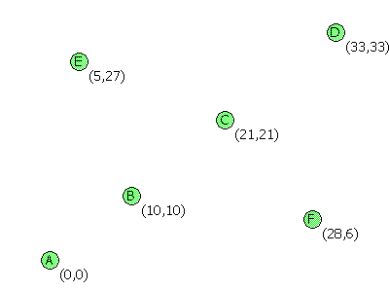
using the group-average proximity measure (the distance between two clusters is the average distance between points, one chosen from each cluster). Which are the pair of the words that will be clustered first? Then, what would be the result of the next clustering step?

Question 5: (2 points)
Cluster the following eight points (with (x, y) representing locations) into three clusters A1(2, 10) A2(2, 5) A3(8, 4) A4(5, 8) A5(7, 5) A6(6, 4) A7(1, 2) A8(4, 9). Initial cluster centers are: A1(2, 10), A4(5, 8) and A7(1, 2). The distance function between two points a=(x1, y1) and b=(x2, y2) is defined as: ρ(a, b) = |x2 – x1| + |y2 – y1| .

Use k-means algorithm to find the three cluster centers after the second iteration.

Question 6: (2 points; for Graduate Students only; Optional for Undergraduate Students)
We want to do an approximate UV-decomposition of the matrix M =
1 | 2 | 3
4 | 5 | 6
7 | 8 | 9
We shall use only a single column for U and a single row for V, so the goal is to make the product UV as close as possible to M. Initially, we shall set V to [5,5,5] and make the entries of U unknown. Then in the first step, we choose the values of x, y, and z that minimize the root-mean-square error (RMSE) between the product
  x
  y
  z
  5 | 5 | 5
and the matrix M.
Find the values of x, y, and z that minimize the RMSE.

Feedback Question: (Ungraded)
Based on the topics we discussed in class, which topic did you find the most confusing (if any)? How can this material be further improved for next year? If you wish to submit any anonymous feedback please type your response, print it, and ask Linda (in the main office) to put it in my mailbox. (Note that you should submit the rest of the homework via Email or hardcopy)

Honor Code:
We must adhere to the Academic Honesty Code. Anything less than complete adherence to its rules and intent is unacceptable and will be met with the processes defined therein. Honesty in your academic work will develop into professional integrity.
You are allowed to consult your colleagues; however, sharing software solutions or answers are not allowed. The consultation with your colleagues must be done via the Q&A platform on Piazza. Your submission should be based on your own work. This is an individual-based assignment.

