UNIVERSITY OF CALIFORNIA
College of Engineering
Department of Electrical Engineering and Computer Sciences

EE 130/230A Prof. Liu
Fall 2013

Homework Assignment #9
Due at the beginning of class on Thursday, 10/31/13

Problem 1: MOS Capacitor - Areal Charge Density
Consider an n+ poly-Si-gated capacitor (Φ_{M} = 4.05 eV) with oxide thickness x_{o} = 3 nm and p-type Si substrate doping N_{A} = 10¹⁷ cm⁻³, maintained at T = 300K.
- Calculate the flatband voltage, V_{FB}.
- Calculate the threshold voltage, V_{T}.
- Plot the value of the total areal charge density (in C/cm²) in the Si as a function of gate voltage V_{G}, for each of the regions of operation (accumulation, depletion and inversion). Indicate the numerical values of areal charge density in the Si at V_{G} = V_{T} and V_{G} = V_{T} + 1 Volt.

Problem 2: MOS Threshold Voltage
Consider an NMOS capacitor with oxide thickness x_{o} = 3 nm, maintained at T = 300K.
- Generate a plot of the threshold voltage (on a linear scale) vs. Si dopant concentration (on a log scale), for p-type substrate doping N_{A} ranging from 10¹⁵ cm⁻³ to 10¹⁸ cm⁻³, for two cases:
  - Gate material is n+ poly-Si (Φ_{M} = 4.05 eV)
  - Gate material is a “mid-gap” metal (Φ_{M} = 4.6 eV)
- From your plot in (a), estimate the value of N_{A} corresponding to a threshold voltage of 0.5 V, for each of the two cases.
- Qualitatively, how would your answers to part (b) change if the oxide thickness x_{o} were to be decreased (e.g. to 2 nm)?

Problem 3: MOS C-V characteristic
The gate capacitance vs. gate voltage characteristic of a p+ poly-Si gated MOS capacitor (Φ_{M} = 5.17 eV) of area 1×10⁻⁴ cm², is as shown:
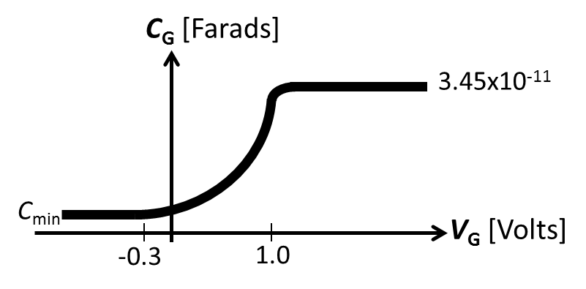
- Is the semiconductor (silicon) substrate doped n-type or p-type? Explain briefly.
- Is the measurement frequency low or high? Explain briefly.
- What is the thickness of the gate oxide (SiO₂), x_{o}?
- Estimate the semiconductor doping concentration. (Note: You should be able to estimate the flatband voltage, V_{FB}, from the C-V plot above.)
- Based on your answers to (c) and (d), calculate the value of the minimum capacitance, C_{min}.

