Quiz 12 (the real #12!) Name ___________________________________________

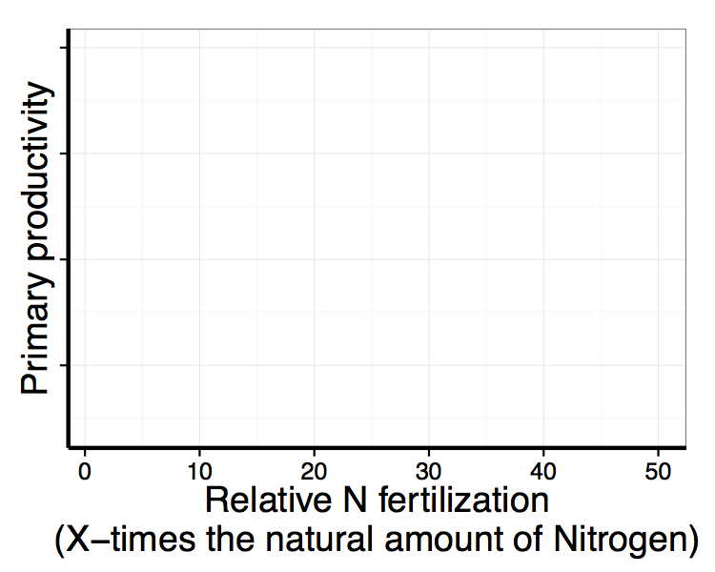
- Which is the largest pool of Nitrogen?
  - Rocks / Lithosphere
  - Water / Hydrosphere
  - Air / Atmosphere
  - Living organisms / Biosphere

- Which is the largest pool of Phosphorus?
  - Rocks / Lithosphere
  - Water / Hydrosphere
  - Air / Atmosphere
  - Living organisms / Biosphere

- On the axes to the right, show how primary productivity
changes with N fertilization.

- What is the most important impact of acid rain on ecosystems?
  - It increases rates of immobilization
  - It increases rates of decomposition
  - It increases rates of nutrient leaching
  - Acidic water is harder for plants to take up

- True or False: Nutrient cycling in terrestrial ecosystems can directly influence nutrient cycling in aquatic ecosystems, but the reverse is not true.

Quiz 12 (the real #12!) Name ___________________________________________

- Which is the largest pool of Nitrogen?
  - Rocks / Lithosphere
  - Water / Hydrosphere
  - Air / Atmosphere
  - Living organisms / Biosphere

- Which is the largest pool of Phosphorus?
  - Rocks / Lithosphere
  - Water / Hydrosphere
  - Air / Atmosphere
  - Living organisms / Biosphere

- On the axes to the right, show how primary productivity
changes with N fertilization.

- What is the most important impact of acid rain on ecosystems?
  - It increases rates of immobilization
  - It increases rates of decomposition
  - It increases rates of nutrient leaching
  - Acidic water is harder for plants to take up

- True or False: Nutrient cycling in terrestrial ecosystems can directly influence nutrient cycling in aquatic ecosystems, but the reverse is not true.

