DW&DM
Spring 2017 UOL

Assignment # 1
Instructor: Noman Saleem
Due Date: 9th of March 2017 in class

Q 1.

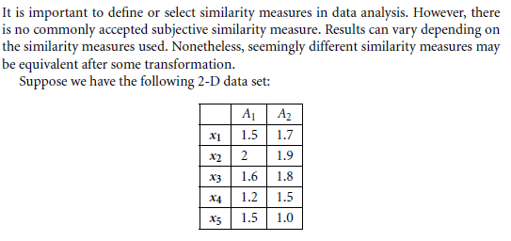

Consider the data as 2-D data points. Given a new data point, x = (1.4, 1.6) as a query, rank the database points based on similarity with the query using Euclidean distance, Manhattan distance, and cosine similarity.
(b) Normalize the data set to make the norm of each data point equal to 1. Use Euclidean distance on the transformed data to rank the data points.

Q 2.
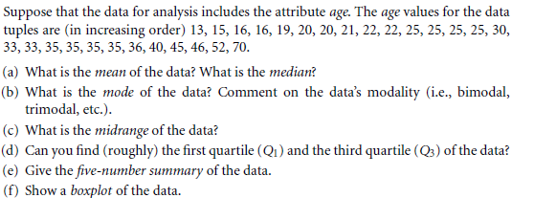
Q 3.
